3.54: In terms of the range R and the time t that the balloon is in the air, the car’s original distance is 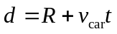. The time t can be expressed in terms of the range and the horizontal component of velocity, 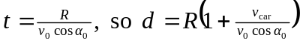. Using 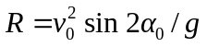 and the given values yields 

